

MODUL PERKULIAHAN 2023

General English for Student

- 4 LANGUAGE SKILLS
- Grammar:
- VOCABULARY

 | Fakultas |  | Program Studi |  | TatapMuka |  | Kode MK |  | DisusunOleh |  | 
 | FEB |  | EM/EA |  | 1 |  |  |  | Drs. Budiantoro, MA

Phone Conversation: Most Commonly Used English Phrases on the Phone

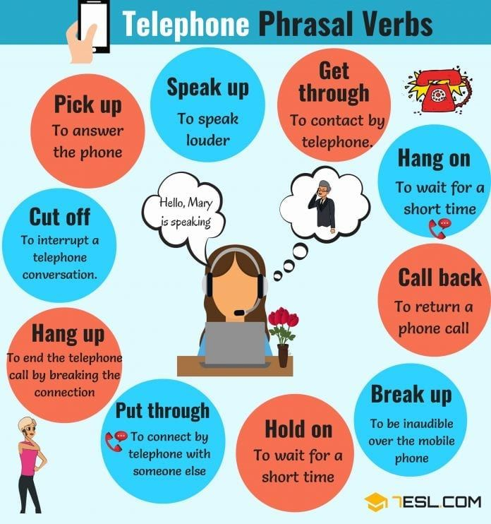

Communicative skills are very important. Communicating properly on the phone is especially important, as the person you are speaking to cannot see your facial movement or your body language. They rely completely on what you are saying, and how you are speaking, to understand you fully.
As well as speaking clearly when talking on the phone, it is vital to use the right level of formality. If you are too formal, people might find it difficult to feel comfortable when talking to you. If you are too informal, they might think you are being rude!
Generally speaking, when you are calling in a business context (making calls related to employment, finances, law, health or applications of any sort), you should show politeness by using words like:
- could
- would
- can
- may
when making a request. When you ask for something, or receive help or information, you should use:
- please
- thank you
- thank you very much.
It is also okay to use some of the informal features of the English language such as short forms, phrasal verbs and words like okay and bye – in other words, everyday English! So phrases like:
- ‘I’m off to a conference, okay, bye’,
- ‘Hang on a moment, I’ll put you through’
are perfectly acceptable, as long as the overall tone of your voice is polite and friendly.
If it is more of an informal phone conversation (speaking to a friend, family member, close work colleague or even a friend of a friend), then a high level of formality is usually not required, but you should still speak with a polite manner, as it is seen as respectful.
It’s fine to use less formal phrases in these conversations, such as
- ‘thanks’
- ‘cheers’
- ‘bye’
- ‘okay’
- ‘no problem’
Another useful thing to remember is, it’s better to ask for help or clarification when you’re having a telephone conversation, than to pretend you understand something that you didn’t. It is absolutely fine to use phrases like:
- ‘Could you repeat that please?’
- ‘Could you speak a little more slowly please?’
- ‘Would you mind spelling that for me please?’
Using phrases like these will help you to have a more successful phone call, and may save you from any problems later on. You could always say:
- ‘I’m afraid the line is quite bad’,
if you can’t hear very well.
It also a good idea to practise words, phrases and vocabulary that you might need to use, before the call! So to help you out a little, here is a list of commonly used phrases:
ecommended for you:
List of Sentence Connectors in English with Examples!
Difference between Connect, Contact, Conduct and Communicate
How to introduce yourself in English: Tips and Phrases

Introduction / Making Contact
If answering a business call, start by introducing yourself or if the caller fails to identify themselves, then you could ask them to state who they are by using the following phrases:
Formal
- ‘Hello’
- ‘Good Morning’
- ‘Good Afternoon’
- ‘This is ___ speaking’
- ‘Could I speak to ___ please?’
- ‘I would like to speak to ___’
- ‘I’m trying to contact ___’
Informal
- ‘Hello’
- ‘Hi, it’s ___ here’
- ‘I am trying to get in touch with ___’
- ‘Is ___ there please?’
Check your Grammar ››

Giving more information
This would probably be used in a business context mainly, but could sometimes be helpful in an informal conversation too. It is good to specify where you are calling from, if you feel it may be helpful to the person you are calling.
Formal
- ‘I am calling from ___
- I’m calling on behalf of ___’
Informal
- ‘I’m in the post office at the moment, and I just needed ___’

Taking / Receiving a Call
You may need to use these if you are answering someone else’s phone, because they are unable to answer it themselves, or if you are answering an office phone.
Formal
- ‘Hello, this is ___ speaking’
- ‘___ speaking, how may I help you?’
Informal
- ‘Hello, John’s phone’
Asking for more information / Making a request
If you need to ask for a specific person, then phrase your request as a polite question, if you only have an extension number and no name, you can say so. If you’re calling for a specific reason, just explain briefly what it is.
Formal
- ‘May I ask who’s calling please?’
- ‘Can I ask whom I’m speaking to please?’
- ‘Where are you calling from?’
- ‘Is that definitely the right name/number?’
- ‘Could I speak to someone who ___?’
- ‘I would like to make a reservation please’
- ‘Could you put me through to extension number ___ please?’
Informal
- ‘Who’s calling please?’
- ‘Who’s speaking?’
- ‘Who is it?’
- Whom am I speaking to?

Asking the caller to wait / Transferring a call
If you are transferring a caller to someone else, you should let them know that you are doing so, just so they know what is happening, as the silent tone could be mistaken for a disconnected line! If you are the one being transferred, you will often hear the person use the following phrases:
Formal
- ‘Could you hold on a moment please’
- ‘Just a moment please’
- ‘Hold the line please’
- ‘I’ll just put you through’
- ‘I’ll just transfer you now’
Informal
- ‘Hold on a minute’
- ‘Just a minute’
- ‘Okay, wait a moment please’

Giving Negative Information
If you are the one answering a call, you might not be able to help the caller. You can use some of the following phrases in these circumstances:
Formal
- ‘I’m afraid the line is busy at the moment’
- ‘That line is engaged at the moment, could you call back later please?’
- ‘I’m afraid ___’s busy at the moment, can I take a message?’
- ‘I’m sorry, he’s out of the office today’
- ‘You may have dialled the wrong number’
- ‘I’m afraid there’s no one here by that name’
Informal
- ‘Sorry, ___’s not here’
- ‘___ is out at the moment’

Telephone Problems
If you don’t understand everything the other person is saying, be honest. Tell the other person immediately, otherwise you might miss some important information! Most people will appreciate your honesty, and will be happy to oblige.
Formal
- ‘I’m afraid I can’t hear you very well’
- ‘Would you mind speaking up a bit please?’
- I’m afraid my English isn’t very good, could you speak slowly please?’
- ‘Could you repeat that please?’
Informal
- ‘Sorry, I didn’t catch that’
- ‘Say that again please?’
- ‘I can’t hear you very well’
- ‘Sorry, this line is quite bad’

Leaving / Taking a Message
If the person you’re calling is not available, be prepared to leave a message. This could be a voicemail, (which is a digital voice recording system), or an answering machine (this records messages onto a tape). If you’re leaving a message with another person, they’ll either ask if you want to leave a message, or you could request to leave a message with them. Be sure to leave your number, if you want the other person to call you back!
Formal
- ‘Can I take your name and number please?’
- ‘Can I leave a message please?’
- ‘Could you please ask ___ to call me back?’
- ‘Could you spell that for me please?’
- ‘Can I just check the spelling of that please?’
Informal
- ‘I’ll ask him to ring you when ___ gets back’
- ‘Could you tell ___ that I called please?’
- ‘I’ll let ___ know that you rang’
Saying Goodbye
The easiest part of the conversation! Simply be polite, and speak with a friendly manner.
Formal
- ‘Thank you for calling’
- ‘Have a good day’
- ‘Goodbye’
Informal
- ‘Bye!’
- ‘Talk soon’
- ‘Speak to you again soon’
Remember your manners!
It’s very important to be polite on the telephone, use phrases like could you, would you like to, and to make requests, use please. Always remember to finish a conversation with thank you and good bye.
Write it down!
If you’re nervous about speaking on the phone in English, then it may be helpful to write a brief script or a few bullet points on that you need to say.
If you will be speaking to someone you don’t know, it helps to have things written down in front of you, to calm your nerves!
If you have a brief outline of what you need to say, it will help to organise your thoughts beforehand, and to use it as a reference during the call, if you get confused.
Phrasal verbs
One thing you could do to improve your telephone skills is to learn some of the phrasal verbs that are commonly used in English telephone conversations.

Common Phrasal Verbs
1. hold on
means wait
- ‘Could you hold on a moment please?’
2. hang on
also means wait! (informal)
- ‘Could you hang on a moment please?’
3. put (a call) through
means to connect one caller to another
- ‘I’m just going to put you through now.’
4. get through
to be connected to someone on the phone
- ‘I can’t get through to his line at the moment, could you call back later please?’
5. hang up
means to put the receiver down
- ‘I think the operator hung up on me, the line just went dead!’
6. call up
is to make a telephone call (mainly used in American English or slang)
- ‘I’ll call up the theatre, and find out about tickets.’
7. call back
is to return someone’s call
- ‘I’ll ask him to call you back, when he gets home.’
8. pick up
means to answer a call / lift the receiver to take a call
- ‘No one is picking up, maybe they’re not at home.’
9. get off (the phone)
means to stop talking on the phone
- ‘When he gets off the other phone, I’ll pass on your message.’
10. get back to (someone)
means to return someone’s call
- ‘When do you think she’ll be able to get back to me?’
11. cut off
to be disconnected abruptly during a telephone conversation
- ‘I think we got cut off, I can’t hear her anymore.’
12. switch off/turn off
is to deactivate (a cell phone/mobile phone)
- ‘Sorry you couldn’t get through to me. My phone was switched off, because the battery had died.’
13. speak up
means to talk louder
- ‘I’m afraid I can’t hear you very well, could you speak up a little please?’
Skype English Lesson with a native AMERICAN or BRITISH teacher ››
Recommended for you:
CAN or MAY? The difference between CAN and MAY!
Useful English Phrases For Running A Business Meeting
Hold on means ‘wait’ – and hang on means ‘wait’ too. Be careful not to confuse hang on with hang up! Hang up means ‘finish the call by breaking the connection’ – in other words: ‘put the phone down.’
Another phrasal verb with the same meaning as hang up is ring off, but this isn’t as commonly used as some of the other phrasal verbs listed above.
The opposite of hang up / ring off is ring up – if you ring somebody up, you make a phone call. And if you pick up the phone (or pick the phone up), you answer a call when the phone rings.
“Hang on a second…”
If you are talking to a receptionist, secretary or switchboard operator, they may ask you to hang on while they put you through – put through means to connect your call to another telephone. With this verb, the object (you, me, him, her etc.) goes in the middle of the verb: put you through.
But if you can’t get through to (contact on the phone) the person you want to talk to, you might be able to leave a message asking them to call you back.
Call back means to return a phone call – and if you use an object (you, me, him, her, etc.), it goes in the middle of the verb: call you back.
Now you can start making those calls!

TUGAS 1:
  - BUATLAH KALIMAT ANDA SENDIRI DENGAN 1-13 WORDS/ PHRASES SEPERTI CONTOH DI ATAS
  - BUAT VIDEO YOU TUBE AMBIL TOPIC DARI SUB BAB YG ADA DISINI DENGAN JURASI MAX 5 MINUTES DAN LINK YOU TUBE DI CANTUMKAN DI TUGAS MS WORD DAN UPLOAD

